**Car-Service Management System - Requirement 1**

Your friend, a mechanical engineer is very passionate about cars and wants to be an entrepreneur. He decides to start his own car service center and with his knowledge about cars has the capability to service all different brands of cars. You are also very keen to help him out in any means possible.   
One fine day, your friend approaches you to help him setup and automate the process of tracking various customers and their service feedbacks. You decide to quickly build a small system to solve the problem.   
Based on the class diagram given below, you start to build a prototype of the application. 

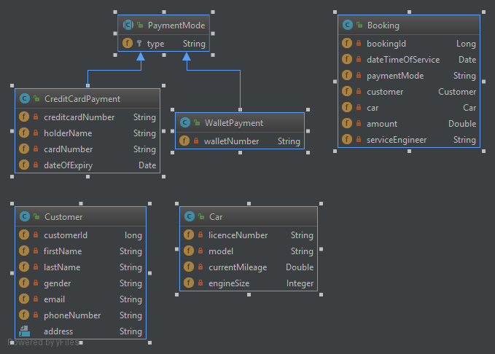

**Requirement 1:**

Let’s start off by creating a customer class based on the below mentioned specifications.

1. Create a Customer Class with the following attributes:

|  |  |
| --- | --- |
| **Member Field Name** | **Type** |
| customerId | Long |
| firstName | String |
| lastName | String |
| gender | String |
| email | String |
| phoneNumber | String |
| address | String |

1. Mark all the attributes as private
2. Create / Generate appropriate Getters & Setters
3. Add a default constructor and a parameterized constructor to take in all attributes in the given order: Customer(Long customerId, String firstName, String lastName, String gender, String email, String phoneNumber, String address)
4. When the “customer” object is printed, it should display the following details: [Override the toString method]  
   Print format:  
   **Customer:firstname,lastname  
   Contact details:phoneNumber,email,address**
5. Two customers are considered same if they have the same name (both firstname and lastname), email and phone number. Implement the logic in the appropriate function. (Case – Insensitive) [Override the equals method]

The Input to your program would be details of two customers, you need to display their details as given in "requirement e" and compare the two customers and display if the customers are same or unique.

**Sample INPUT & OUTPUT 1:**

Customer1 :  
customer id:  
**1**  
first name:  
**Arun**  
last name:  
**Kumar**  
gender:  
**Male**  
email:  
**arun123@gmail.com**  
phone number:  
**9897969594**  
address:  
**Coimbatore North**  
Customer2 :  
customer id:  
**123**  
first name:  
**Arun**  
last name:  
**Kumar**  
gender:  
**Male**  
email:  
**arun123@gmail.com**  
phone number:  
**9897969594**  
address:  
**Coimbatore North**  
  
Customer 1  
Customer:Arun,Kumar  
Contact details:9897969594,arun123@gmail.com,Coimbatore North  
  
Customer 2  
Customer:Arun,Kumar  
Contact details:9897969594,arun123@gmail.com,Coimbatore North  
Customer 1 is same as Customer 2

**Sample Input and Output 2:**

Customer1 :

customer id:

**1**

first name:

**Vijay**

last name:

**Kumar**

gender:

**Male**

email:

**Vijayajit@gmail.com**

phone number:

**9876541234**

address:

**North Chennai**

Customer2 :

customer id:

**23**

first name:

**Karmega**

last name:

**Kulazhi**

gender:

**Female**

email:

**Karmegam@gmail.com**

phone number:

**7785674563**

address:

**Kurangani, Theni, Tamilnadu**

Customer 1

Customer:Vijay,Kumar

Contact details:9876541234,Vijayajit@gmail.com,North Chennai

Customer 2

Customer:Karmega,Kulazhi

Contact details:7785674563,Karmegam@gmail.com,Kurangani, Theni, Tamilnadu

Customer 1 and Customer 2 are different